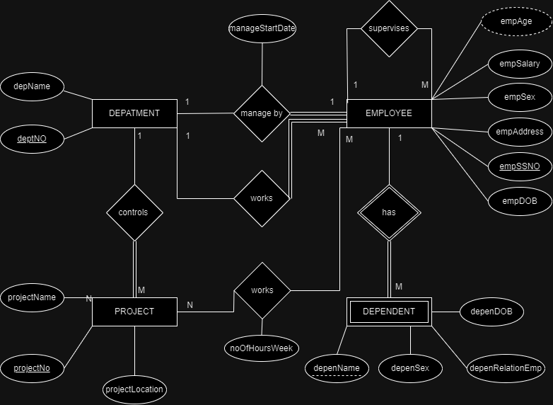

Assumptions

* **One Employee** can work on several **Projects.**
* **One Department** manages a particular **One Employee.**
* **One Employee** manages a particular **One Department.**
* **One Project** controls a particular **One Department.**
* **One Department** works with **Many Employees.**
* **One Employee** works on **Many Projects.**
* **One Employee** supervises **Many Employees.**
* **One Employee** supervises a particular **One Employee.**
* **One Dependent** has a particular **One Employee.**